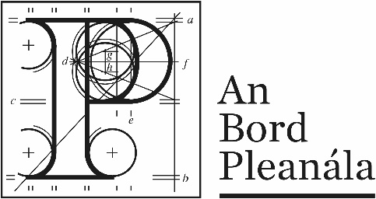 | Memorandum
 | ABP-314019-22

To: | Senior / Planning Inspector
From: | Ashling Doherty, Executive Officer
Re: | Demolition of the existing building on site, construction of 350 no. apartments and associated site works.  At the junction of Santry Avenue a Swords Road, Santry, Dublin 9 – occupying the site of the existing Chadwick Builders Merchants.
Date: | 19th September 2022
- Please find hereunder an application for permission for the above-mentioned proposed development. A fee of €63,689.28 has been submitted with the application. Two printed copies and three electronic copies of the application documentation have been received in accordance with article 297(5) of the Planning and Development (Strategic Housing Development) Regulations 2017.

- A website has been created: (www.santryavenueshd2.ie)

- The planning application was valid.

- Pre-application consultations in accordance with section 5 of the Act of 2016 were held with under reference ABP- 312127-21. ABP’s Opinion was that the documents submitted constitute a reasonable basis for an application for strategic infrastructure development.

- The planning application contains documents submitted in accordance with the Planning and Development (Housing) and Residential Tenancies Act 2016.

- A EIAR has been submitted with this application.

- The Appropriate Assessment Screening Report concludes that on the basis of objective information, the proposed development, individually or in combination with other plans or projects, is not likely to have significant effects on any European sites.

- The Material Contravention Statement can be permitted under the provisions of the Planning and Development (Housing) and Residential Tenancies Act 2016.

- A submission was received from Irish Water on 10th August 2022 which states that the Applicant has engaged with Irish Water in respect of design proposal for which they have been issued a Statement of Design Acceptance for the development.

- The public notice was published in the Irish Daily Star newspaper dated 28th June 2022. The site notice was erected on 28th June 2022.

- The prescribed bodies for the purposes of the application are set out in article 295 of the Planning and Development (Strategic Housing Development) Regulations 2017. The following bodies were circulated with the application documentation in accordance with the advice from ABP: 312127-21
- Transport Infrastructure Ireland
- National Transport Authority
- Dublin City Childcare Committee
- Irish Aviation Authority
- Dublin Airport Operator
- Fingal County Council
- Irish Water

Copies of the letters have been submitted

- Deadline for making submissions was 10th August 2022 and 38 submissions have been received.

- The Chief Executives report of Dublin City Council North was received on 31st August 2022.

- Site history identified by the applicant:

ABP-310910-21 Mixed Refuse

File for assessment and report.

